引用数据库：



连接数据库：

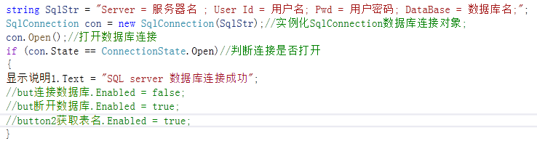

断开数据库：

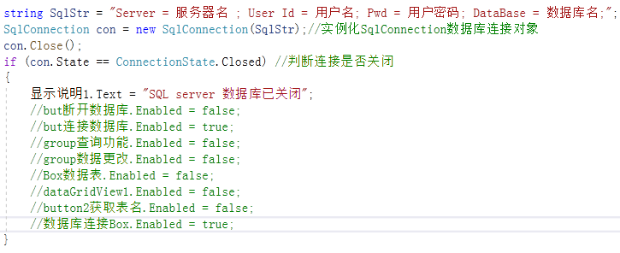

读取数据库中的表全部数据：

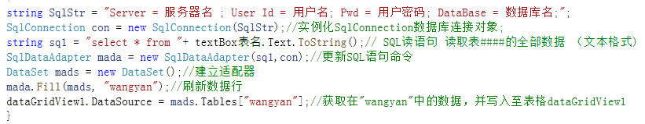

获取数据表所有表名：

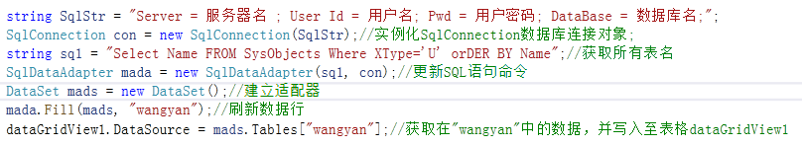

查询数据库单一对应数据：

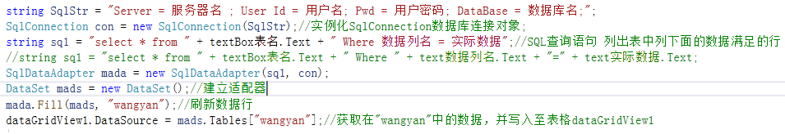

删除满足条件的数据行：

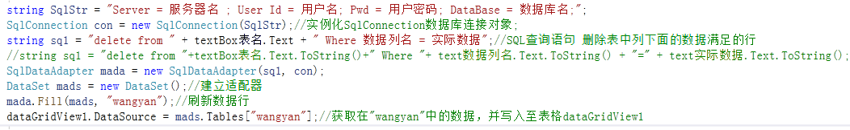

软件界面：

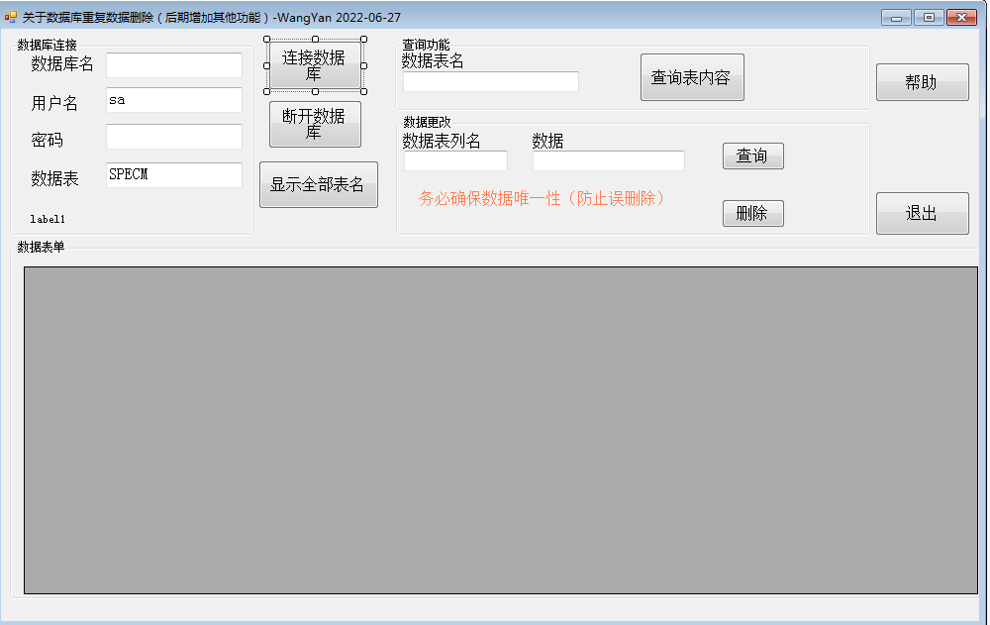

**源程序：**

using System;

using System.Collections.Generic;

using System.ComponentModel;

using System.Data;

using System.Drawing;

using System.Linq;

using System.Text;

using System.Windows.Forms;

using System.Data.SqlClient;//数据库使用

namespace 针对SQL数据库_简单SQL语句程序

{

public partial class Form1 : Form

{

public Form1()

{

InitializeComponent();

}

private void Form1_Load_1(object sender, EventArgs e)

{

but断开数据库.Enabled = false;

but连接数据库.Enabled = true;

显示说明1.Text = "SQL server 连接状态未知";

group查询功能.Enabled = false;

group数据更改.Enabled = false;

Box数据表.Enabled = false;

dataGridView1.Enabled = false;

button2获取表名.Enabled = false;

}

private void But连接数据库_Click(object sender, EventArgs e)

{

try

{

//创建数据库连接字符串

string SqlStr = "Server=" + text数据库名.Text.ToString() + ";User Id =" + text用户名.Text.ToString() + "; Pwd =" + text密码.Text.ToString() + ";DataBase = " + text数据表.Text.ToString() + ";";

//string SqlStr = "Server = 服务器名 ; User Id = 用户名; Pwd = 用户密码; DataBase = 数据库名;";

SqlConnection con = new SqlConnection(SqlStr);//实例化SqlConnection数据库连接对象;

con.Open();//打开数据库连接

if (con.State == ConnectionState.Open)//判断连接是否打开

{

显示说明1.Text = "SQL server 数据库连接成功";

but连接数据库.Enabled = false;

but断开数据库.Enabled = true;

button2获取表名.Enabled = true;

}

}

catch (Exception ex)

{

MessageBox.Show(ex.ToString());

}

}

private void But断开数据库_Click_1(object sender, EventArgs e)

{

//string SqlStr = "Server = 服务器名 ; User Id = 用户名; Pwd = 用户密码; DataBase = 数据库名;";

string SqlStr = "Server=" + text数据库名.Text.ToString() + ";User Id =" + text用户名.Text.ToString() + "; Pwd =" + text密码.Text.ToString() + ";DataBase = " + text数据表.Text.ToString() + ";";

SqlConnection con = new SqlConnection(SqlStr);//实例化SqlConnection数据库连接对象

con.Close();

if (con.State == ConnectionState.Closed) //判断连接是否关闭

{

显示说明1.Text = "SQL server 数据库已关闭";

but断开数据库.Enabled = false;

but连接数据库.Enabled = true;

group查询功能.Enabled = false;

group数据更改.Enabled = false;

Box数据表.Enabled = false;

dataGridView1.Enabled = false;

button2获取表名.Enabled = false;

数据库连接Box.Enabled = true;

}

}

private void Button1_Click(object sender, EventArgs e)

{

try

{

string SqlStr = "Server=" + text数据库名.Text.ToString() + ";User Id =" + text用户名.Text.ToString() + "; Pwd =" + text密码.Text.ToString() + ";DataBase = " + text数据表.Text.ToString() + ";";

//string SqlStr = "Server = 服务器名 ; User Id = 用户名; Pwd = 用户密码; DataBase = 数据库名;";

SqlConnection con = new SqlConnection(SqlStr);//实例化SqlConnection数据库连接对象;

string sq1 = "select * from "+ textBox表名.Text.ToString();// SQL读语句 读取表####的全部数据 （文本格式)

SqlDataAdapter mada = new SqlDataAdapter(sq1,con);//更新SQL语句命令

DataSet mads = new DataSet();//建立适配器

mada.Fill(mads, "wangyan");//刷新数据行

dataGridView1.DataSource = mads.Tables["wangyan"];//获取在"wangyan"中的数据，并写入至表格dataGridView1

}

catch (Exception ex)

{

MessageBox.Show(ex.ToString());

}

}

private void Button2获取表名_Click(object sender, EventArgs e)

{

try

{

string SqlStr = "Server=" + text数据库名.Text.ToString() + ";User Id =" + text用户名.Text.ToString() + "; Pwd =" + text密码.Text.ToString() + ";DataBase = " + text数据表.Text.ToString() + ";";

//string SqlStr = "Server = 服务器名 ; User Id = 用户名; Pwd = 用户密码; DataBase = 数据库名;";

SqlConnection con = new SqlConnection(SqlStr);//实例化SqlConnection数据库连接对象;

string sq1 = "Select Name FROM SysObjects Where XType='U' orDER BY Name";//获取所有表名

SqlDataAdapter mada = new SqlDataAdapter(sq1, con);//更新SQL语句命令

DataSet mads = new DataSet();//建立适配器

mada.Fill(mads, "wangyan");//刷新数据行

dataGridView1.DataSource = mads.Tables["wangyan"];//获取在"wangyan"中的数据，并写入至表格dataGridView1

group查询功能.Enabled = true;

group数据更改.Enabled = true;

Box数据表.Enabled = true;

dataGridView1.Enabled = true;

数据库连接Box.Enabled = false;

}

catch (Exception ex)

{

MessageBox.Show(ex.ToString());

}

}

private void Butt查询单一数据_Click(object sender, EventArgs e)

{

try

{

string SqlStr = "Server=" + text数据库名.Text.ToString() + ";User Id =" + text用户名.Text.ToString() + "; Pwd =" + text密码.Text.ToString() + ";DataBase = " + text数据表.Text.ToString() + ";";

//string SqlStr = "Server = 服务器名 ; User Id = 用户名; Pwd = 用户密码; DataBase = 数据库名;";

SqlConnection con = new SqlConnection(SqlStr);//实例化SqlConnection数据库连接对象;

//string sq1 = "select * from " + textBox表名.Text + " Where 数据列名 = 实际数据";//SQL查询语句 列出表中列下面的数据满足的行

string sq1 = "select * from " + textBox表名.Text + " Where " + text数据列名.Text + "=" + text实际数据.Text;

SqlDataAdapter mada = new SqlDataAdapter(sq1, con);

DataSet mads = new DataSet();//建立适配器

mada.Fill(mads, "wangyan");//刷新数据行

dataGridView1.DataSource = mads.Tables["wangyan"];//获取在"wangyan"中的数据，并写入至表格dataGridView1

//con.Dispose();//释放SQL资源

}

catch (Exception ex)

{

MessageBox.Show(ex.ToString());

}

}

private void Butt数据删除_Click(object sender, EventArgs e)

{

try

{

string SqlStr = "Server=" + text数据库名.Text.ToString() + ";User Id =" + text用户名.Text.ToString() + "; Pwd =" + text密码.Text.ToString() + ";DataBase = " + text数据表.Text.ToString() + ";";

//string SqlStr = "Server = 服务器名 ; User Id = 用户名; Pwd = 用户密码; DataBase = 数据库名;";

SqlConnection con = new SqlConnection(SqlStr);//实例化SqlConnection数据库连接对象;

//string sq1 = "delete from " + textBox表名.Text + " Where 数据列名 = 实际数据";//SQL查询语句 删除表中列下面的数据满足的行

string sq1 = "delete from "+textBox表名.Text.ToString()+" Where "+ text数据列名.Text.ToString() + "=" + text实际数据.Text.ToString();

SqlDataAdapter mada = new SqlDataAdapter(sq1, con);

DataSet mads = new DataSet();//建立适配器

mada.Fill(mads, "wangyan");//刷新数据行

dataGridView1.DataSource = mads.Tables["wangyan"];//获取在"wangyan"中的数据，并写入至表格dataGridView1

}

catch (Exception ex)

{

MessageBox.Show(ex.ToString());

}

}

private void But退出_Click(object sender, EventArgs e)

{

Close();

SqlConnection con = new SqlConnection();//实例化SqlConnection数据库连接对象

con.Close();

}

private void But帮助说明_Click(object sender, EventArgs e)

{

MessageBox.Show("说明\n" +

"1.输入数据库名称\n" +

"2.输入用户名 一般为： sa\n" +

"3.输入密码 一般为：Feeler+数字\n" +

"4.输入数据表名 一般为：SSPECM\n" +

"5.点击【连接数据库】\n" +

"6.连接成功后点击【显示全部表名】\n" +

"7.下方表格出现所有表名，选择自己需要的双击复制表名到【数据表名文本框中】\n" +

"8.点击【查询表内容】\n" +

"9.输入关键字【数据表列名】+【数据】\n" +

"10.点击【查询】可以查询目标数据；【删除】可以删除目标数据\n" +

"关于：后期功能阶段性增加\n" +

"WangYan 2022-06-27 V1.0");

}

}

}